**Guide for the du -h command**

**Introduction:**

The du command in Linux helps you find out how much space files and folders are taking up on your system. It's useful for:

* Cleaning up junk files: Identify which directories are using the most space, so you can delete unnecessary files.
* Managing storage efficiently: Make sure you're not wasting disk space and understand how your storage is being used.
* Keeping track of your data: Get a quick overview of your files and folders to see how much space they're consuming.

Basically, it's a handy tool for keeping your Linux system organized and running smoothly!

**Understanding the Command:**

* du stands for "Disk Usage." It's a command-line tool in Unix-like systems that estimates and reports file and directory space usage.
* -h is an option that instructs the command to display sizes in a human-readable format (e.g., MB, GB) for easier interpretation.

**Steps to use the command:**

1. Open a terminal window.
2. Type the command: du -h
3. The output will be like this:

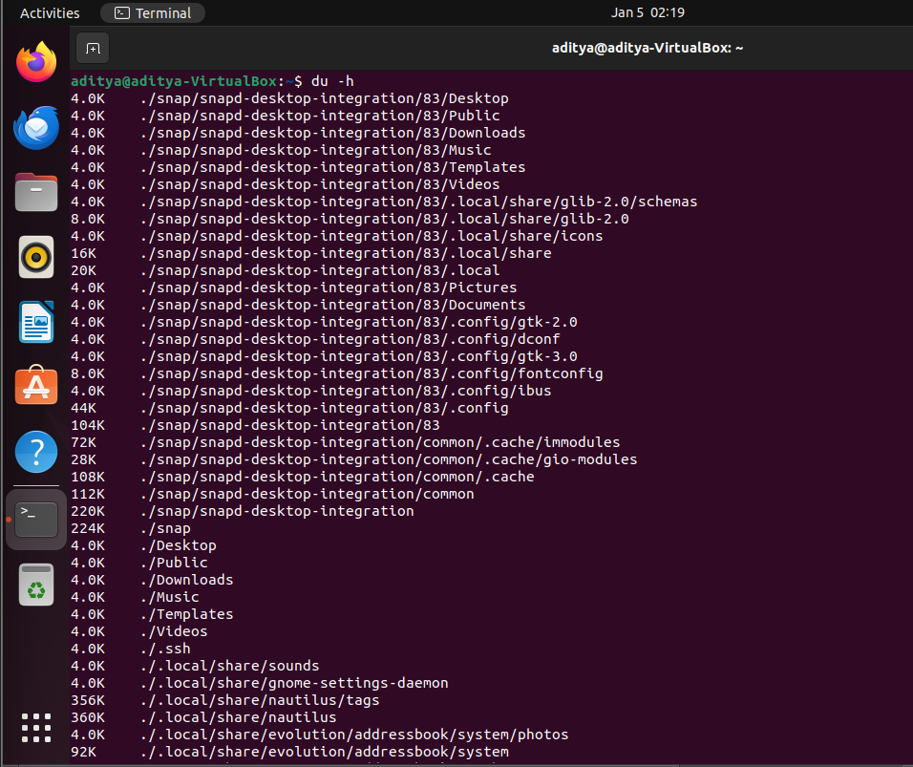

Example:

If you want to know about the particular directory give the path to that directory like this

du -h /home/user/Documents

This will display the disk space usage of the Documents directory and its contents.

Output:

* The command will output the size of each directory and file, along with a total at the end.
* Sizes will be displayed in human-readable units like KB, MB, GB, etc.

**Common Options:**

* du -ah: Lists disk usage for all files and directories, including hidden ones.
* du -sh /path/to/directory: Summarizes disk usage for a specific directory.
* du -ch: Sorts output by decreasing size, showing largest directories first.
* du -h --max-depth=1: Limits output to one level of subdirectories.
* du -h --exclude="*.jpg": Excludes files with the .jpg extension.

Examples:

* Check total disk usage of a directory:

du -sh /home/user/Downloads

* List disk usage of all files, including hidden ones:

du -ah /etc

**Tips:**

* Use sudo if you need to check disk usage of directories that require root permissions.
* Use the sort command to sort the output by size:

du -h | sort -h

* To visualize disk usage in a tree-like structure, use the tree command in conjunction with du -h like this:

tree -h -L 2 | du -h –bytes

**Understanding the Output:**

* The first column shows the file or directory size.
* The second column displays the file or directory name.
* The total disk usage for a directory is shown at the end, preceded by total.

**Key Points:**

* du -h is a valuable tool for understanding how disk space is being utilized.
* The -h option makes the output more readable.
* Additional options like -s, -a and -c provide more flexibility for specific needs.
* Combine du -h with other commands like tree for enhanced visualization.
* Regularly monitor disk usage to prevent storage issues and identify potential space-hogging files or directories.